Steps to Create AWS S3 bucket

1. Login to AWS
2. Open the services drop down

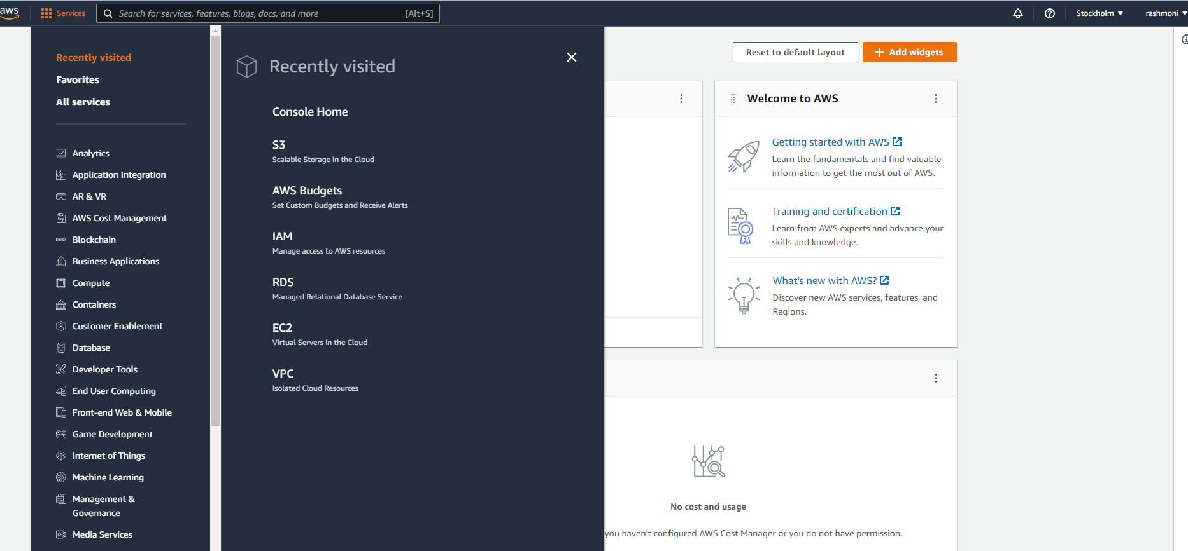

1. Select S3



1. Click on Create Bucket

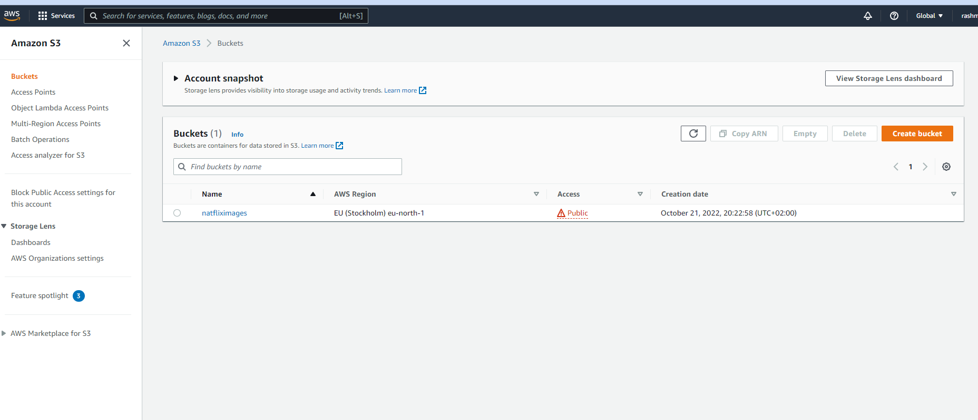

1. Fill as per below diagram ( I enabled public access for the bucket for simplicity in this project but this is not recommended)

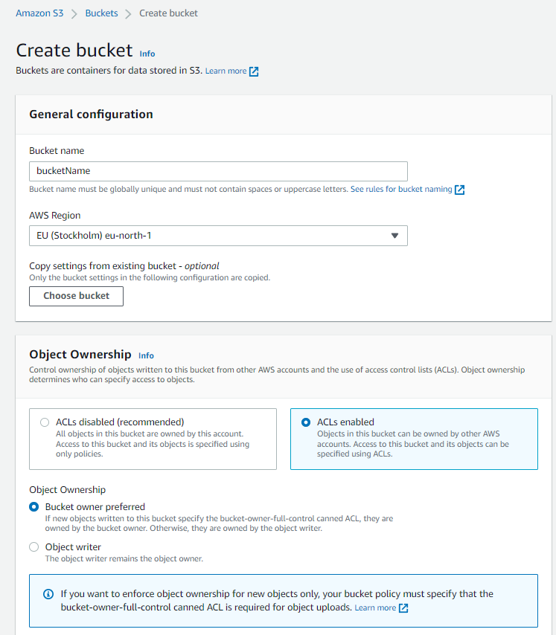

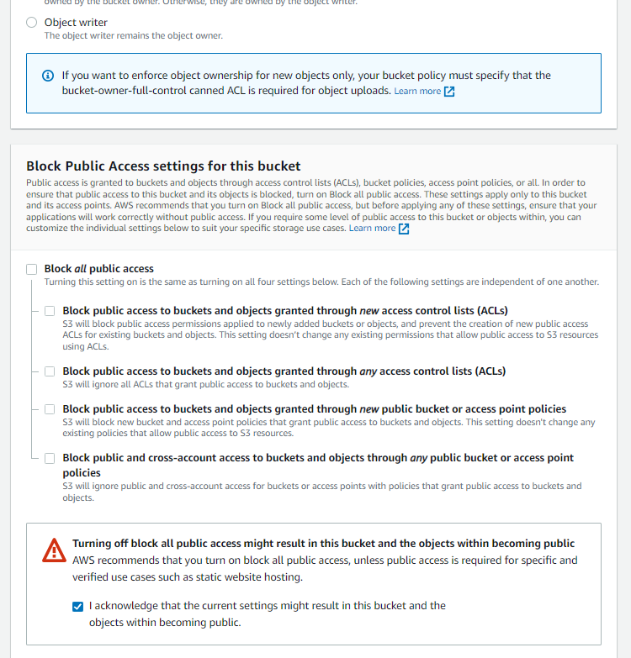

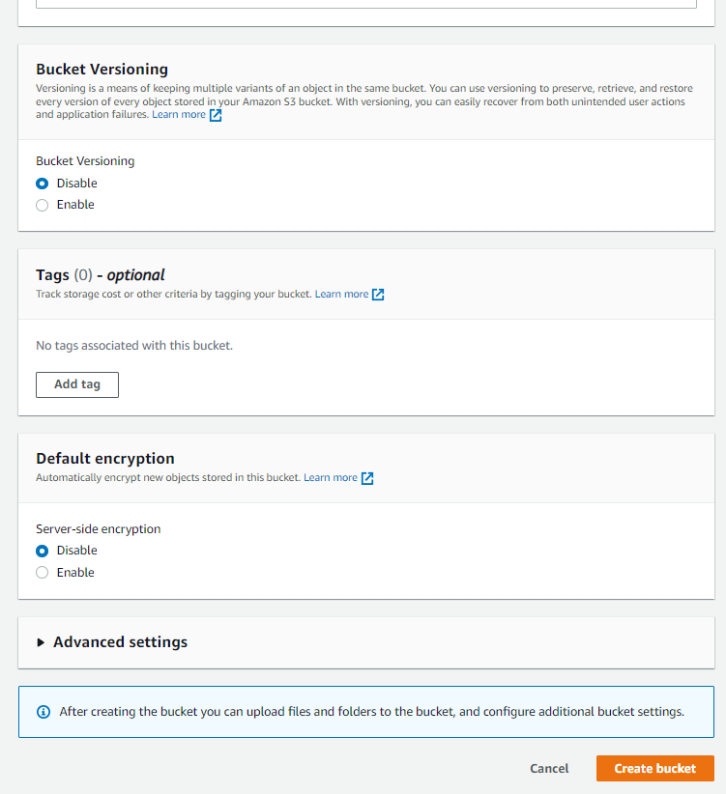

1. Bucket will be created as below

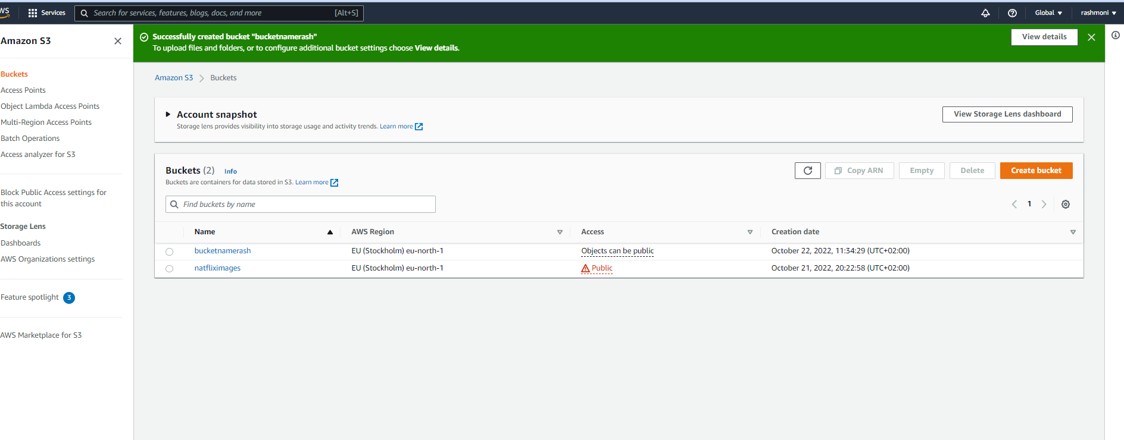

1. Make the object public (it is generally not recommended for production project).

Select the created bucket

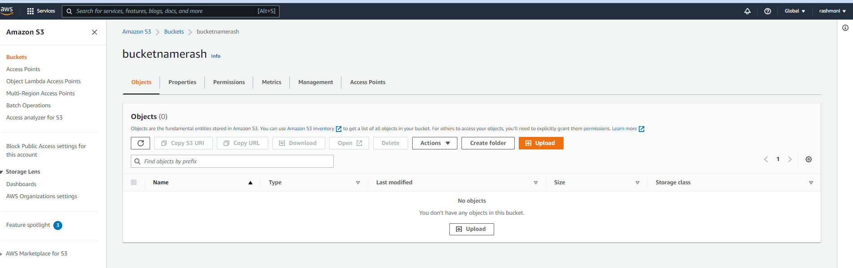

1. Open the permission tab and click on Bucket Policy edit 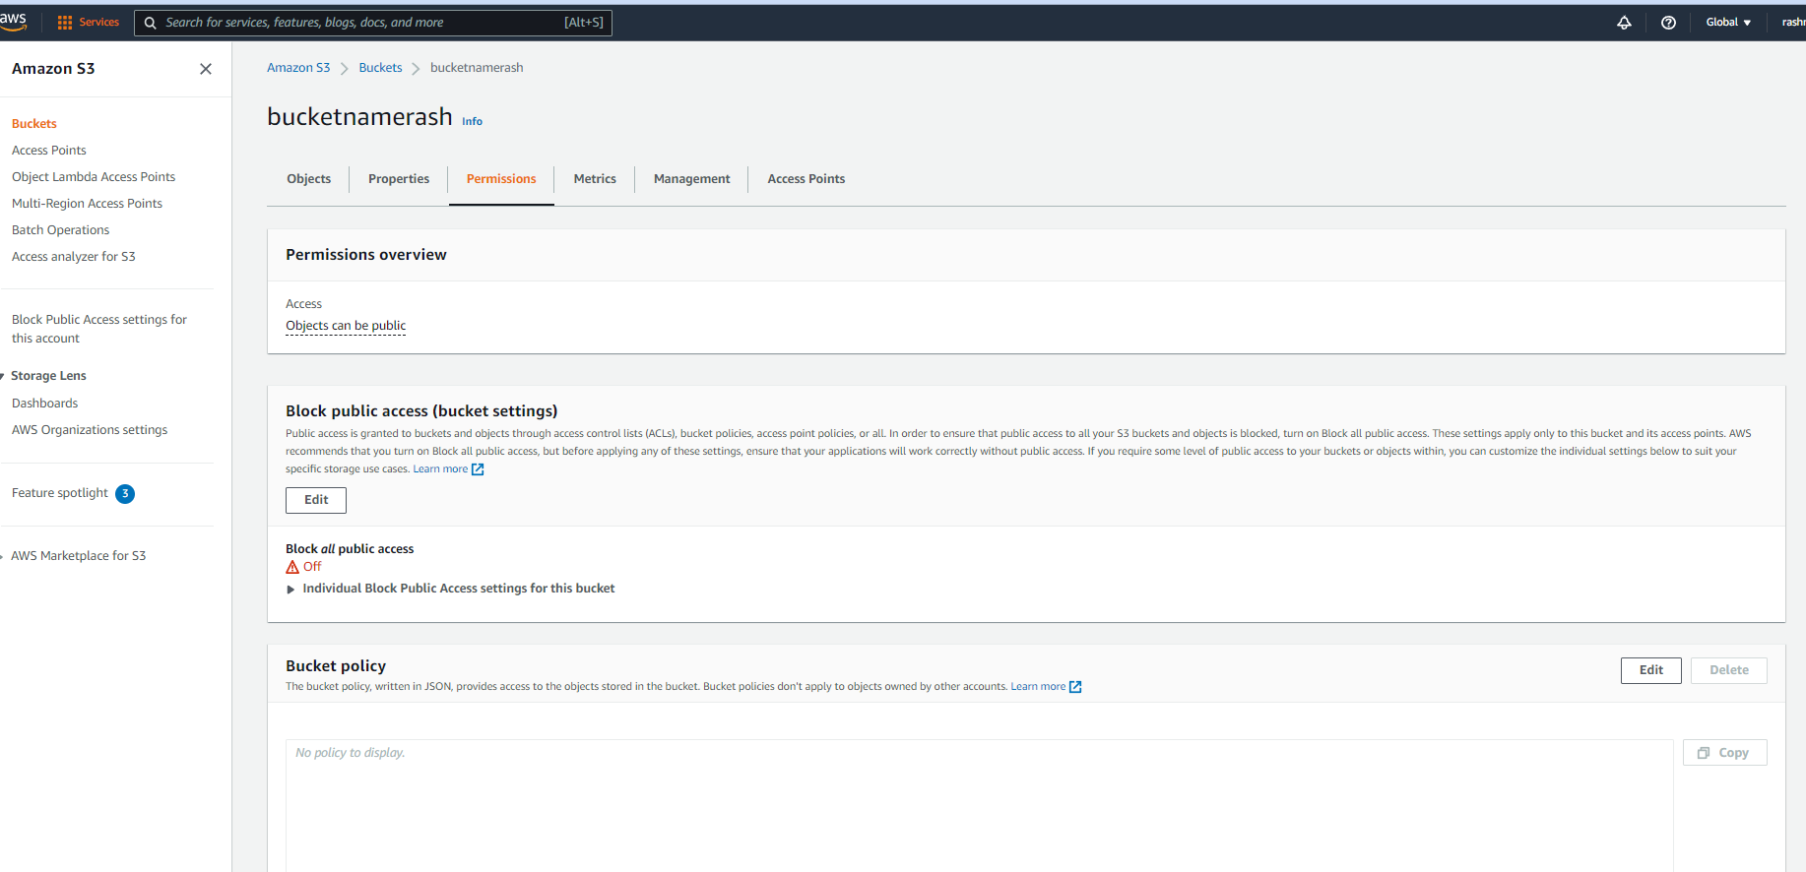
2. Add the below JSON

{

"Version": "2008-10-17",

"Statement": [

{

"Sid": "AllowPublicRead",

"Effect": "Allow",

"Principal": {

"AWS": "*"

},

"Action": "s3:GetObject",

"Resource": "arn:aws:s3:::YOUR-BUCKET_NAME/*"

}

]

}

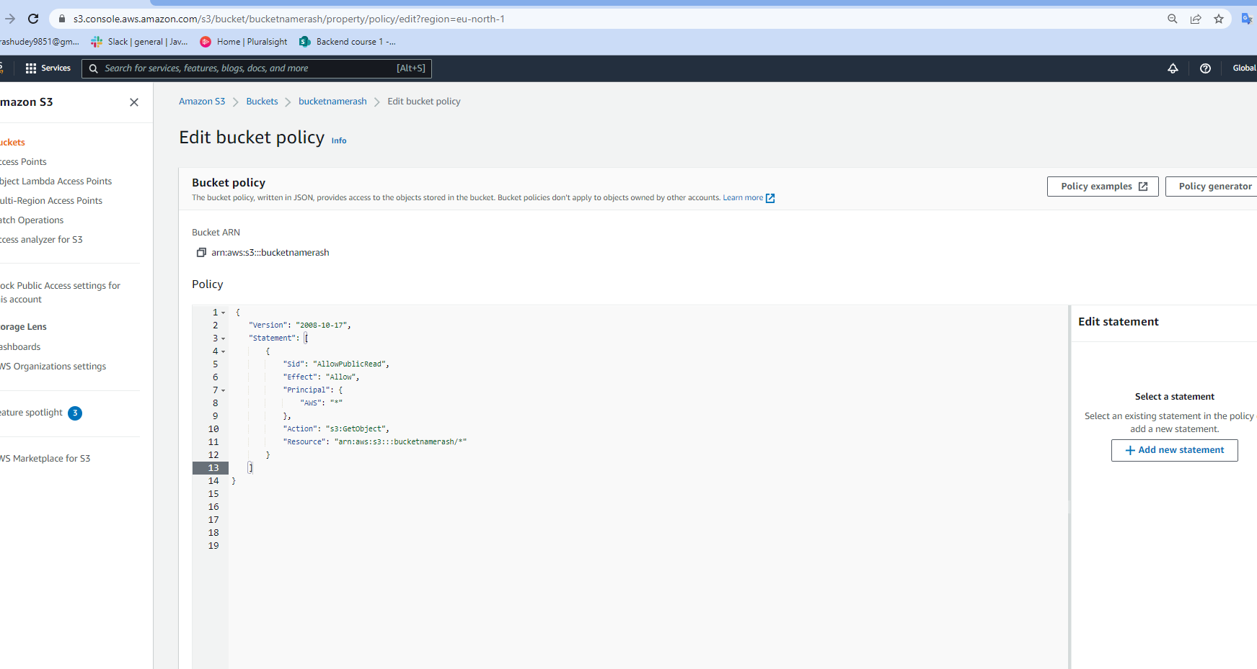

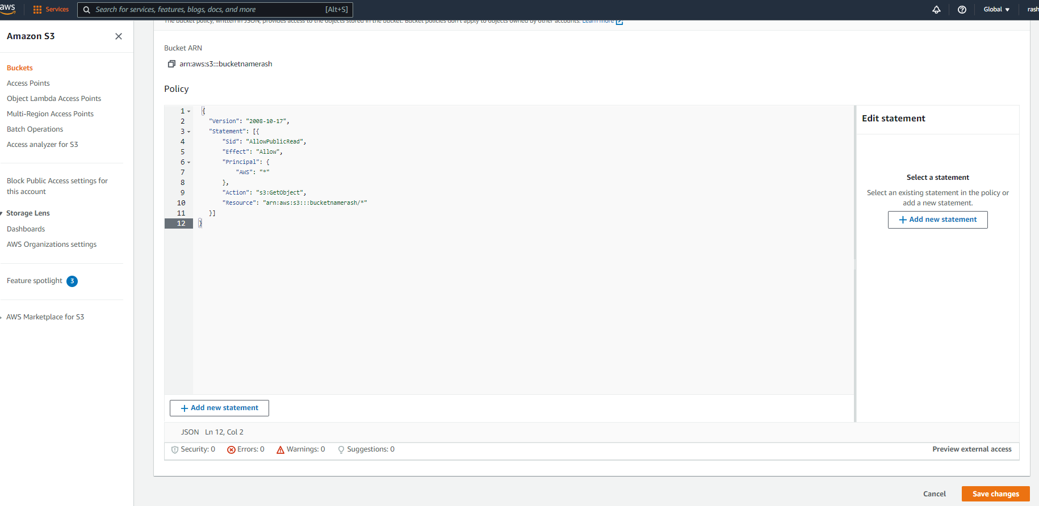

1. Bucket policy updated –

